Normal Speech Production

Breath is taken in through the mouth and nose, passes down through the larynx (voice box), down the trachea (windpipe) to fill up our lungs (inside our rib cage).

When we breathe out the air flows back up the windpipe, through the larynx and out through the mouth and nose.

Inside the larynx are the vocal cords – two muscles that open and close to make voice. Usually when you are breathing they are in the open position to let the air flow easily in and out. When you want to speak they move into the middle so that the air coming up through them will make them vibrate (like the strings of a violin) to produce voice.

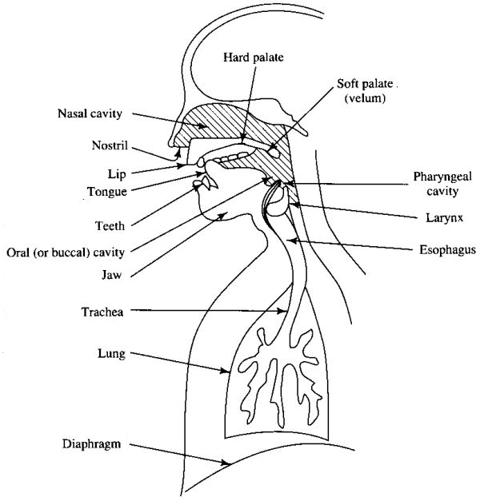
Individual speech sounds (t, s, b, g, a, sh) are produced by shaping our lips, tongue, teeth and soft palate to modify the air (or the voice) as it passes through the throat, mouth and nose.

What is Dysarthria?

Dysarthria is the name given to a speech problem caused by damage to the nerves controlling the muscles of speech.

It can occur following a stroke, head injury, or surgery. It can also be associated with diseases such as MS, or Parkinson’s disease.

Dysarthria can affect the muscles of the throat, mouth and tongue. Nerves in the brain which tell the muscles how and when to move are no longer working properly.

This can result in the muscles becoming:
- Weak
- Slow
- Stiff
- Uncoordinated.

Dysarthria can make speech unclear – Some people comment it’s like trying to talk with a mouth full of marbles, or like speaking after having their mouth numbed at the dentist. Sometimes it sounds as if the person is drunk.

Dysarthria does not affect someone’s ability to understand speech or formulate in their mind what they want to say.

What can go wrong?

- Slurred speech (imprecise production of sounds such as consonants – e.g. /p/ and /s/ - and vowels– e.g. /ee/ and /aa/).
- Speech is often slow, but sometimes too fast for the muscles to keep up
- Speech that sounds monotonous, that is using the same volume or pitch
- Nasal sounding speech
- Altered speech volume (too loud, too soft, or fluctuating)
- Changed voice quality such as sounding breathy, harsh, or strained
- Dribbling and swallowing difficulties may also occur
What Might Help?

Do:
- Make sure you are sitting up straight. Slumped posture inhibits breathing and breath support for speech.

- Exaggerate the movement of your lips, tongue, and jaw to increase the clarity of your speech. Finish each word carefully before beginning the next. Make sounds at the beginning and end of words very clear.

- Break words up and over-emphasise them (don’t run the words together). Break long words into smaller chunks (e.g. hotdog → hot-dog, newspaper → news-pa-per, television → te-le-vi-sion)

- Slow the speech down by:
  - Pausing
  - Taking a ‘top-up’ breath when you pause (this will also help you to maintain volume)
  - ‘Stretching-out’ the words (e.g. blue = ‘b-lue’, scream = ‘s-c-ream’)

- Try not to say too much at one time. Say 2-3 words or less on each breath. Breathe-in more often :
    - To slow down
    - So you don’t run out of breath
    - For louder speech

- Shorten the length of your sentences

- Move closer to the person you are talking to

- Make sure you have your listener’s attention before you start talking:
  - Tap them on the shoulder
  - Say their name

- Make sure you are looking at the listener – they will get extra clues from watching your face, and you can tell if they have not understood

- Reduce background noise (e.g. turn down the radio/ TV or shut the window or door)

- Try and increase the volume of your voice:
  - Use good posture
  - Use short sentences
  - Pause frequently and take a breath before each word or short phrase

- If you haven’t made yourself understood, try saying it another way (choose smaller words, keep it brief – just one or two key words).

- Speak less when you are tired

- Swallow (or spit out) excess saliva before you speak

Don’t:
- Try to speak at your previous rate – you may need to take more time
- Forget to make a special effort with the beginnings and ends of words
- Forget that dentures may need to be altered so that they fit more comfortably
- Give up. Try gestures, pointing, drawing, or writing to get your message across

Remember:

It is easier to say something clearly and more slowly once, than to have to go to the bother of repeating your message all over again.

Friends & Family can help too:

- Be patient - allow more time for conversations

- Making sure you are included in the conversation

- Making sure there is not too much background noise when you are trying to talk

- Reminding you to slow down your speech

- Encouraging you to take a breath more often when you are talking

- Letting you know if they do not understand you

- Asking for clues if they do not understand – i.e. can you point to what you mean?

- Speaking face to face in good light so that they can read your lips to help them make out what you are saying

- Remember that dysarthria does not affect intelligence

Phone calls

- Make sure you are sitting upright, hold the receiver right up to your mouth

- Speak more slowly than usual, remembering to use controlled speech

- You may want to ask the listener to confirm that they have understood you (e.g. by repeating back)

If you need to repeat yourself:

- Do not just repeat in a louder voice, try saying the same thing in a different way, and speak more slowly

Talking Against Noise

It can be more difficult to make yourself understood when it is noisy or when you are in a group. The following suggestions may help:

- Try to turn the noise down rather than raising your voice if you can (e.g. radio/ TV). Make sure you have easy access to the remote control!

- Make sure you have someone’s attention before speaking

- Talk more slowly and use your control strategies

- Use gesture and body language to accompany your speech

- If possible, find a quieter area to talk

